**VIETNAM NATIONAL UNIVERSITY, HO CHI MINH CITY**

**HO CHI MINH CITY UNIVERSITY OF TECHNOLOGY**

**OFFICE FOR INTERNATIONAL STUDY PROGRAMS**

**FACULTY OF TRANSPORTATION**

**Bachelor Project**

**Modelling and simulation using Matlab/Simulink and its**

**applications in Electric Power Steering sytem.**

Part of “Study of Matlab/Simulink and application on simulation and analysis

of mechanical components of the (complete) EPS system”

**Instructor: Ph.D Ngô Đắc Việt**

**Class:** TR4091 – CC01

**Name: Trịnh Tiến Long**

**Student ID: 1852047**

December 22th, 2022, Ho Chi Minh City, Vietnam

**🙦 Semester 221**

**VIETNAM NATIONAL UNIVERSITY OF HO CHI MINH CITY** **SOCIALIST REPUBLIC OF VIETNAM**

**HO CHI MINH UNIVERSITY OF TECHNOLOGY Independence – Freedom – Happiness**

Faculty of Transportation Engineering

Department of Automotive Engineering

**PROJECT MISSION**

1. **Student’s name**: Trịnh Tiến Long - Student ID: 1852047
2. **Major**: Automotive Engineering - Class: CC19OTO1
3. **Thesis title**: Modelling and simulation using Matlab/Simulink and its applications in Electric Power Steering sytem.
4. **Group project title**: Study of Matlab/Simulink and application on simulation and analysis of mechanical components of the (complete) EPS system.
5. **Content:**

* Learning how to use Matlab/Simulink with the Mass-Spring-Damper model.
* Contribution to an analysis of the dynamic behavior of the mechanical components of EPS system
* Analysis of the complete system dynamics of EPS, and implementation of the EPS simulation model on Matlab/Simulink, with simulation results analysis.

1. **Product**:
   * Full report.
   * Poster.
   * Simulink simulation.
2. **Assigned day**: ${19}^{th}$ October, 2022.
3. **Finished day**: ${29}^{th }$ December, 2022.

The content and requirements of the thesis is already approved by the Head of Department of Automotive Engineering.

HCMC, day….... month…… year 2022 HCMC, day… . month…… year 2022

**Head of Department** **Instructor**

**ACKNOWLEDGEMENT**

First and foremost, I want to express my gratitude to my family, who have always been by my side, accompanying, supporting, and assisting me in any way possible so that I can get to where I am now. I want to thank the teachers at Bach Khoa University in general and the Department of Automotive Engineering in particular for their efforts. The knowledge I have gained from teachers over the last four years has assisted me in being brave enough to complete this thesis.

Sincere thanks to PhD. Ngo Dac Viet, PhD. Tran Dang Long created conditions for me to study, practice and conduct field surveys.

Finally, I want to thank the reviewer and department lecturers for sharing their knowledge and providing me with feedback and suggestions so that I could finish this thesis.

Wishing health to parents, family, lecturers in the Faculty of Transportation Engineering as well as lecturers in the Department of Automotive Engineering and all of my friends in class CC19OTO1.

**ABSTRACT**

The aim of this study is to study on automotive Electric Power system by evaluating the technical characteristics of the EPS system, but this study will not evaluate the affect of assisted motor, beside that this study will evaluate the dynamic model of the system. To achieve this goal, this study focus on basis knowledge of Matlab/Simulink with an example and them apply to EPS system. In this study, we intend to learn how to build dynamic equation base on theory of Modeling Mechanical Systems and apply to find out EPS dynamic model. Also this work included how to get familiar with Matlab through an example with Mass – Spring – Damper model .Finally, Matlab/ Simulink environment is used to execute dynamic model and simulate the system, also evaluate the change in steering rack when changing wheel angle, which is inputed by an external torque. Creating m file in Matlab to transfer the parameters of EPS system which are required when simulating in Simulink.

**Table of Contents**

I/ Introduction: 6

**1)** **Objective:** 6

a) Modeling of Mechanical Systems 6

b) Electric Power Steering System 6

c) Matlab/Simulink 6

**2)** **Scope of implementation:** 7

**3)** **Working condition:** 7

**4)** **Technical requirement:** 7

**5)** **Limitation** 7

II/ Theoretical basics: 7

**1.** **Mass damper theory:** 8

**2.** **Some simple mechanical model** 8

a) Rotational mechanical system 8

b) Mechanical system with gear train 8

**3.** **Electric Power Steering Dynamic equations:** 9

III. MATLAB/SIMULINK SIMULATION 12

**1.** **Mass** **– damper system** 12

1.1) Simulink block diagram 12

1.2) Simulation result and discussion 12

**2.** **EPS system** 13

2.1) Simulink block diagram 13

2.2) Block function 14

2.3) Simulation result and discussion 16

V. CONCLUSION AND FUTURE WORK 18

VII. REFERENCE 19

**Table of Figures**

Figure 1: Electric Power Steering system structure 7

Figure 2: Mass - damper model 8

Figure 3: Rotational mechanical system 8

Figure 4: Mechanical system with gear train 9

Figure 5: The overall Electric Power Steering dynamic factors 9

Figure 6: Overall structure of the steering input 10

Figure 7: Overall Rack and Pinion Dynamics 11

Figure 8: Parameter of mass-damper system 12

Figure 9: Mass-damper block diagram 12

Figure 10a-b: Simulation result 13

Figure 12: EPS simulation 14

Figure 12: Result of simulation 16

Figure 13: Second result of simulation 16

Figure 14: Third result of simulation 17

# I/ Introduction:

## **Objective:**

1. Modeling of Mechanical Systems

The task of mathematical modelling is an important step in the analysis and design of control systems. In this project, we will focus on developing mathematical models for the mechanicial system and them apply to EPS system. The mathematical models of system are obtained by applying the fundamental physical laws governing the nature of the components making these systems. For example, Newton’s laws are used in the mathematical modelling of mechanical systems.

These mathematical treatment will be limited to linear, time-invariant ordinary differential equations whose coefficients do not change in time. In real life many systems are nonlinear, but the can be linearized around certain operating ranges about their equilibrium conditions. Real systems are usually quite complex and exact analysis is often impossible. We shall make approximations and reduce the system components to idealized versions whose behaviors are simular to real components.

1. Electric Power Steering System

During the past ten years, EPS has been introduced in gradually increasing numbers. Although electric power steering system offer significant advantages over their hydraulic counterparts, electric motor technology and controls had not reached the point where they could be used in this application until just recently. Electrically assisted power steering is replacing the traditional hydraulic system where the pressure is provided via a pump driven by the vehicles engine. The hydraulic system is constantly running and by using the EPS the fuel consumption can be reduced. In electric and hybrid vehicles, the engine does not run continuously so electric power steering is the only possible solution.

1. Matlab/Simulink

Simulink is a simulation and model-based design environment for dynamic and embedded systems, which are integrated with MATLAB. Simulink was developed by a computer software company MathWorks. Furthermore, it allows to incorporate MATLAB algorithms into models as well as export the simulation results into MATLAB for further analysis.

In Simulink, it is very straightforward to represent and then simulate a mathematical model representing a physical system. Models are represented graphically in Simulink as block diagrams. A wide array of blocks are available to the user in provided libraries for representing various phenomena and models in a range of formats. One of the primary advantages of employing Simulink (and simulation in general) for the analysis of dynamic systems is that it allows us to quickly analyze the response of complicated systems that may be prohibitively difficult to analyze analytically. Simulink is able to numerically approximate the solutions to mathematical models that we are unable to, or don't wish to, solve "by hand."

In general, the mathematical equations representing a given system that serve as the basis for a Simulink model can be derived from physical laws. The focus of this project is that we can get used to MATLAB Simulink with some examples and then apply that knowledge to simulate a simple Electric Power Steering system that usually been used in modern vehicles.

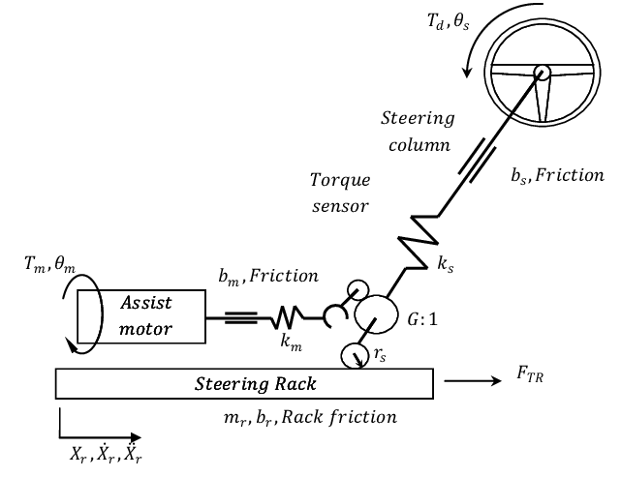

Figure 1: Electric Power Steering system structure

1. **Scope of implementation:**

First part of this project focus on learning how to use MATLab Simulink with one physical model: The Mass-Spring-Damper model

Last part of this project focus on Electric Power Steering model which developed to present vehicle behaviour when driving in normal condition of roads and cars, so it may not be reliable in non-linear conditions (When the vehicle is driven up to its limits). The model developed in this project does not represent the steering condition in parking situations . The model is developed by assuming that the wheels are in contact with the road surface. So, the wheel lift phenomenon is assumed negligible in this model.

1. **Working condition:**

Continuously change to adapt with various conditions.

1. **Technical requirement:**

Working normally in above condition.

1. **Limitation**

This project skips on the effect of motor and effect of forces acting from road to EPS system through wheels that will be finished in next stage of project.

# II/ Theoretical basics:

* + - 1. **Diagram, schematic

         Description automatically generatedMass damper theory:**

Figure 2: Mass - damper model

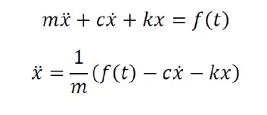The Mass-Spring-Damper model is one of the most common models used by engineers to model kinematic systems. From human tissue to bridges, this straightforward model features three mechanisms and can be summarized as the following second-order differential equation:

Here x represents the displacement of the object with mass m away from its resting position. The mass is subject to some spring force characterized by spring constant k and a damping force that resists change in motion with damping coefficient c. The function g here can be thought of as some input to the system that could depend on position, velocity, or time. For this example, we can vary f(t) as an input.

* + - 1. **Some simple mechanical model**

## Rotational mechanical system

Figure : Rotational mechanical system

For the system shown in Fig 3, we can write equations for disk 1 and disk 2:

This example can be used to explain the equation for torsion bar’s parameter (Ks and Bs in the next part).

1. Mechanical system with gear train

For the system shown in Fig 4, we can write equations for the system:

Base on these simple mechanical model, we can apply to find out equations for EPS system in the next part.

Figure : Mechanical system with gear train

* + - 1. **Electric Power Steering Dynamic equations:**

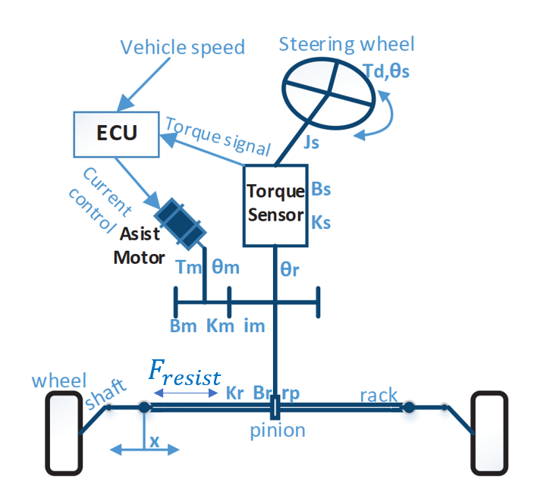

Figure 5: The overall Electric Power Steering dynamic factors

**Figure 5** illustrates the physical structure of a steering system. The structure components are a column type steering system which include the steering wheel, steering column, the rack and the pinion mechanism. The assistance motor is a permanent magnet synchronous motor, connected to the steering shaft through gears and provides the assisting torque needed by the driver to steer the vehicle. The input torque from the steering wheel is measured by a torque sensor mounted on the steering column and connected to the electronic control unit. The assistance torque produced by the motor act on the wheel via rack and pinion system. Different amount of assistance torque is applied depends on the driving conditions, which is realized with a specific control logic implemented in the ECU.

Using Newton's law and neglecting no necessary factors the equations of EPS can be derived:

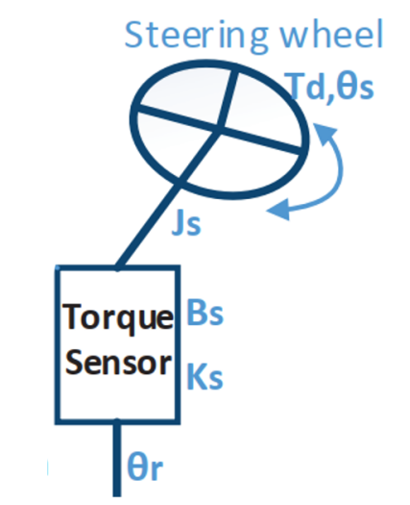

Figure 6: Overall structure of the steering input

* The dynamic equations from the steering wheel to steering column:

$$J_{s}×\frac{{d^{2}}_{θ_{s}}}{dt^{2}}=T_{d}-K_{s}\left(θ_{s}-θ_{r}\right)-B_{s}×\frac{d_{θ_{s}}}{dt^{2}}$$

While:

$J_{s}:$ Inertia of steering wheel and steering column (kg. $m^{2})$

$B_{s}:$ Viscous damping coefficient of steering column (deboost of steering column) (Nm. ${rad}^{-1})$

$K_{s}:$ Rigidity of torsional bar (Nm. ${rad}^{-1}$)

$θ_{s}:$ Turn angle of steering wheel (rad)

$θ_{r}:$ Turn angle of output steering axle (rad)

$T_{d}:$ Input torque of steering wheel (N.m)

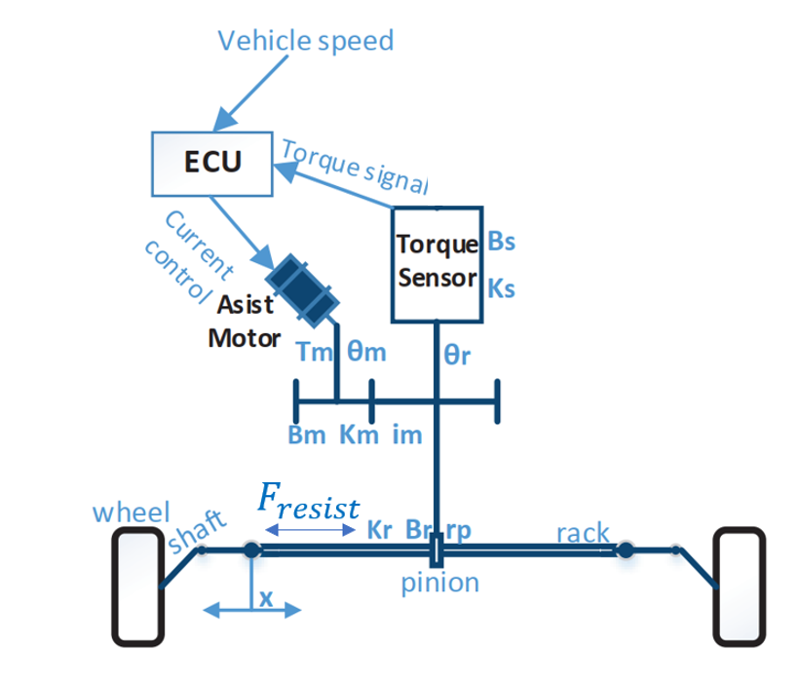

Figure : Overall Rack and Pinion Dynamics

* Finally, rack and pinion section is illustrated in Figure 7 and governed by the equation:

$$m×\frac{d^{2}x}{dt^{2}}=\frac{1}{r_{p}}\left[K_{s}\left(θ_{s}-θ_{r}\right)\right]-B_{r}×\frac{d_{x}}{dt}-K_{r}×x$$

While:

m: mass of the pinion and rack (kg)

$r_{p}:$ pinion radius ($m)$

$B_{r}:$ Viscous damping coefficient of rack and pinion (deboost of the rack and pinion) (Nm. ${rad}^{-1})$

$θ_{r}:$ Turn angle of output steering axle (rad)

$θ_{s}:$ Turn angle of steering wheel (rad)

$K_{s}:$ Rigidity of torsional bar (Nm. ${rad}^{-1}$)

We can see in above equation we have the resist force apply on the rack. This force that resists the motion of the rack when the driver is steering

# III. MATLAB/SIMULINK SIMULATION

**Mass** **– damper system**

Figure : Parameter of mass-damper system

### 1.1) Simulink block diagram

Figure : Mass-damper block diagram

### 1.2) Simulation result and discussion

* The position and velocity of the spring-damper system are generated by solving the developed transfer function using MATLAB. The displacement graph is shown in Fig 10b while the velocity graph is shown in Fig 10a.
* For the given parameters of the system, the position vs. time response in MATLAB gives the maximum value equal to 1.961 m. Similarly, the maximum velocity is found to be 9.761 m/s.
* Simulink model uses the solver ode45 for solving the differential equation for the spring-mass-damper system.

Figure a-b: Simulation result

1. **EPS system**

### 2.1) Simulink block diagram

|  |  |  |
| --- | --- | --- |
| Symbols | Value | Name |
| $$J_{s}$$ | 0.0012 [kg $m^{2}$] | Inertia of steering wheel and steering column |
| $$B_{s}$$ | 0.26 [Nm ${rad}^{-1}$] | Viscous damping coefficient of steering column |
| $$K_{s}$$ | 115 [Nm ${rad}^{-1}$] | Rigidity of torsional bar |
| $$θ_{s}$$ | [Rad] | Turn angle of steering wheel |
| $$θ_{r}$$ | [Rad] | Turn angle of output steering axle |
| $$T_{d}$$ | [Nm] | Input torque of steering wheel |
| $$T_{m}$$ | [Nm] | Output torque of the motor |
| $$K_{m}$$ | 125 [Nm ${rad}^{-1}]$ | Rigidity of the motor and reducer |
| $$B_{m}$$ | [Nm ${rad}^{-1}]$ | Viscous damping coefficient of the motor |
| $$i_{m}$$ | 7.225 | Reduction ratio of reducer |
| $$θ_{m}$$ | [Rad] | Turn angle of motor |
| $$K_{r}$$ | 91064 [N $m^{-1}$] | Linear rigidity |
| $$B_{r}$$ | 653.203 [Nm ${rad}^{-1}]$ | Viscous damping coefficient of rack and pinion |
| $$r_{p}$$ | 0.007783 [m] | Pinion radius |
| x | m | Rack displacement |
| $$m_{r}$$ | 32 [kG] | Mass of the rack and pinion system |
| m | [kG] | Mass of the vehicle |
| $$l$$ | [m] | Wheelbase |
| $$b$$ | 1.684 [m] | Track width |
| g | 9.8 [m $s^{-2}]$ | Gravitational acceleration |
| $$C_{f}$$ | 70000 [N ${rad}^{-1}$] | Cornering stiffness of front axle |
| $$l_{1}$$ | 1.32484 [m] | Distance from front axle to center of vehicle |
| $$l_{2}$$ | 1.532 [m] | Distance from rear axle to center of vehicle |
| $$L_{arm}$$ | 0.08 [m] | Disturnbance force moment arm |

Table 1: Electric Power Steering Parameters

Figure : EPS simulation

### 2.2) Block function

|  |  |
| --- | --- |
| **Block in Simulink** |  |
| **Function that block represent for** | $$J_{s}×\frac{{d^{2}}_{θ_{s}}}{dt^{2}}=T_{d}-K_{s}\left(θ_{s}-θ_{r}\right)-B_{s}×\frac{d_{θ_{s}}}{dt^{2}}$$ |

Table 2: Block for first equation

|  |  |
| --- | --- |
| **Block in Simulink** |  |
| **Function that block represent for** | $$m×\frac{d^{2}x}{dt^{2}}=\frac{1}{r_{p}}\left[K_{s}\left(θ_{s}-θ_{r}\right)\right]-B_{r}×\frac{d_{x}}{dt}-K_{r}×x$$ |

Table 3: Block for second equation

### 2.3) Simulation result and discussion

Figure : Result of simulation

The inputs to this system are the torque generated by the driver. Since we present a model of the power steering system, details of the tire dynamics are neglected. The outputs of the mechanical subsystem are the displacement of the rack, X, and the rotational displacement of the steering column θS.

As we can see from Fig 12, with θS changed from 0 to nearly 1 rad, x jumped to approximately 7x10-3 m. Input touque at 3s is 5Nm.

Figure : Second result of simulation

In second result, the input in steering wheel angle is generated in a sine shape which goes from -300 degrees to 300 degrees. As we can see, the rack displacement also changed in sine shape also, going from -0.04m from center to 0.04m (positive direction goes from left to right)

Figure : Third result of simulation

Same configuration with second results but we increase frequency of changing in steering wheel angle by 2 (so the period will be decreased by 2). The result is the same as we expected: rack displacement x also rise the speed of changing by +2.

# V. CONCLUSION AND FUTURE WORK

Basis theory about modeling mechanical system and Matlab/Simulink are included.

Simulate a mass – damper system in order to learn how Matlab/Simulink work has been done in this project also.

Moreover, a dynamic model of a power steering system is developed by applying above knowledge. The model can be used for performance evaluation and can be easily adapted to fit in a larger vehicle handling model. It can also be used for the design of other power steering systems, where it allows the designer to test changes in dynamic conditions. Other variations, such as pinion radius, stiffness of the torsion bar or piston area can be made as well, and the results tested in the same manner. The simulation results agree to a great extent with the real test results. Although how good that is, this project is made only for education purposes and has limitation shown in the beginning.

After having simulation about EPS system, we can easily obtain the relevant between steering wheel and rack displacement. In the future, this project can contain the support from motor, also can deal with load which are restrain, aligning moment acting from road back to the system. We also include the effect of camber, caster and kingpin angle to EPS system.

# VII. REFERENCE

1. Cossalter, V. (2010). *Motorcycle Dynamics*. Lulu.
2. Genta. (2020). *The automotive chassis*. Springer International Publishing.
3. Hiremath, R. R., & Isha, T. B. (2019). Modelling and simulation of electric power steering system using permanent magnet synchronous motor. *IOP Conference Series: Materials Science and Engineering*, *561*(1), 012124. https://doi.org/10.1088/1757-899x/561/1/012124
4. Jazar, R. N. (2008). *Vehicle dynamics: Theory and applications*. Springer.
5. Nasir, M. Z., Dwijotomo, A., Abdullah, M. A., Hassan, M. Z., & Hudha, K. (2012). Hardware-in-the-loop simulation for automatic rack and pinion steering system. *Applied Mechanics and Materials*, *229-231*, 2135–2139. https://doi.org/10.4028/www.scientific.net/amm.229-231.2135
6. Nemes, R.-O., Ruba, M., & Martis, C. (2018). Integration of real-time electric power steering system MATLAB/Simulink model into National Instruments Veristand Environment. *2018 IEEE 18th International Power Electronics and Motion Control Conference (PEMC)*. https://doi.org/10.1109/epepemc.2018.8521888
7. Pacejka, H. B. (2002). *Tyres and vehicle dynamics*. Butterworth-Heinemann.
8. Qun, Z., & Juhua, H. (2009). Modeling and simulation of the Electric Power Steering System. *2009 Pacific-Asia Conference on Circuits, Communications and Systems*. https://doi.org/10.1109/paccs.2009.67
9. Ingale, A. (no date) “Modeling Mass-Spring-Damper System using Simscape,” *Journal of Engineering Research and Application* [Preprint]. Available at: https://doi.org/10.9790/9622-0801033033.
10. Sh., A., H., E. and A., E.-H. (2006) “Side-stick control of power rack and pinion steering system,” *The International Conference on Applied Mechanics and Mechanical Engineering*, 12(12), pp. 383–396. Available at: https://doi.org/10.21608/amme.2006.41261.